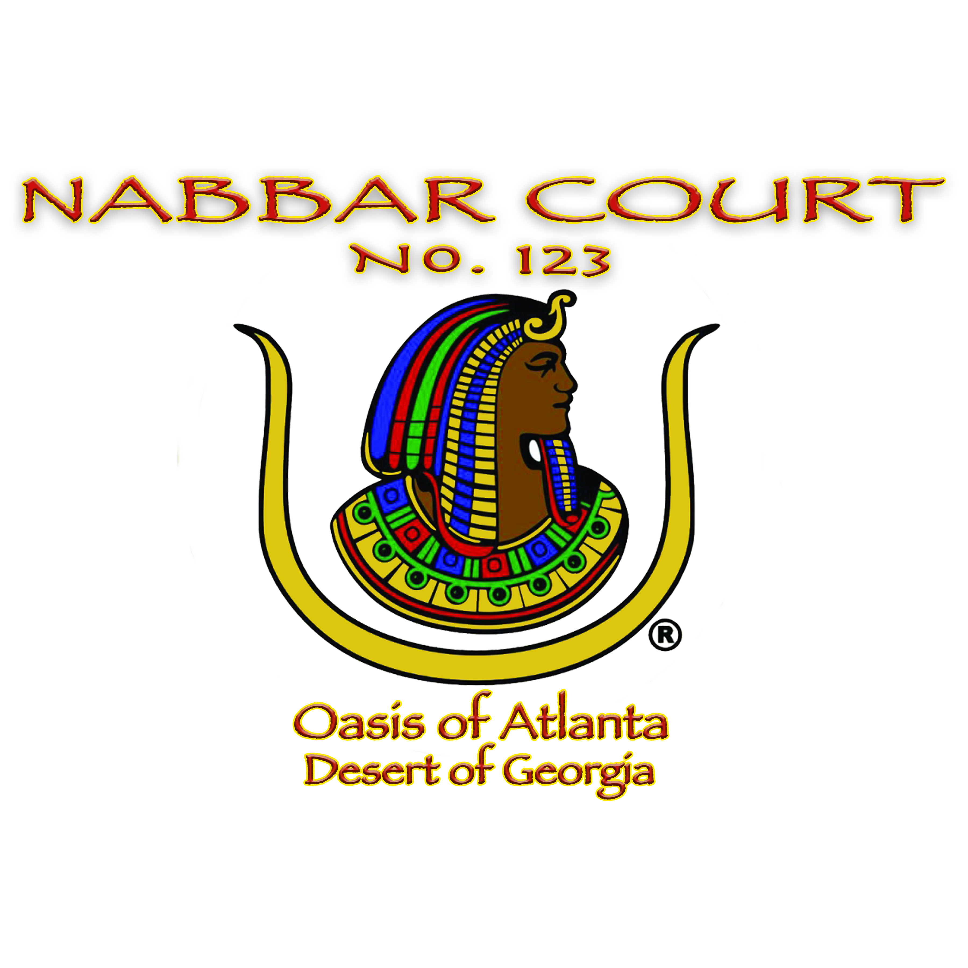

Check Request Form

Name:
Date:
Committee/Unit:

CHECK RECIPIENT | PURPOSE | AMOUNT
 | Total
*** If a Unit is transferring funds (Queen’s Contest, Talent & Scholarship, etc.), please specify.
Note: Please submit this completed form to the Recordress, Dt. Cynthia Henry, at nabbarcourtrecordress123@gmail.com. Submit all receipts to the Treasurer, Dt. Laniki Smith, at laniki_smith2017@att.net.

